

PROJECT REPORT

PROJECT TITLE – TO-DO LIST CONSOLE PLANNAR
NAME- ISHITA SAHA
REGISTRATION NUMBER – 25BCY10122
PROGRAM – B.TECH
COURSE CODE – CSE2001
COURSE NAME – CSE(CYBER SECURITY AND DIGITAL FORENSICS)
FACULTY – DR VISHNU VARTHANAN
ACADEMIC YEAR – 2025 – 29

INTRODUCTION
This project delivers a Dynamic To-Do List Console Agent, an user friendly interactive, menu-driven knowledge-based system built through Prolog logic programming language. It addresses the real world need for an efficient and reliable task manager.
The system defines a dynamic task/3 predicate to represent eacg to-do item with their unique ID in sequential, non-repeating way. The system supports user input for eg: adding new tasks. The system performs other querying and organising tasks to view tasks, marking them as complete or to completely deleting the tasks.
This system serves as a powerful practical demonstration of logic programming applied to solve everyday problems.

PROBLEM STATEMENT

Design and implement an intelligent system that allows a user to create, view, update and delete tasks through a simple console based logic. The system should assign each task a unique ID and track its status.

Constraints: Unique ID enforcement, Status of task, Input from the user,

OBJECTIVES
1.To develop a console-based To-Do List plannar that allows users to add,view,update and delete tasks in an organised way.
2.To implement dynamic task storage using Prolog predicates.
3.To provide a simple, menu-driven interface that guides users through all available operations.
4.To determine the use of Prolog concepts such as dynamic facts, recursion and input/output in a practical, real world style application.

NON – FUNCTIONAL REQUIREMENTS
- Performance: The system shall respond promptly to user inputs.

- Usability: The system shall have a simple, clear and user-friendly text-based menu interface that guides the user.

- Reliability: The system shall handle invalid inputs gracefully, displaying appropriate error messages.

- Maintainability: The code shall be modular with clear predicate definitions.

PROLOG CODE
% Prolog To-Do List Console Application

:- dynamic task/3.

load_tasks :-
retractall(task(_, _, _)),
write('Starting a new session. Dynamic memory cleared.'), nl.

save_tasks :-
write('NOTE: File saving is disabled in this environment (SWISH sandbox).'), nl,
write('Your current tasks will be lost when the session ends.'), nl.

next_id(ID) :-
% Find all existing IDs
findall(TID, task(TID, _, _), IDs),
( IDs = []
-> % If no tasks exist, start at 1
ID = 1
; % Otherwise, the new ID is the maximum existing ID + 1
max_list(IDs, MaxID),
ID is MaxID + 1
).

% add_task/0: Prompts for a new task description and adds it to the database.
add_task :-
write('Enter task description: '),
% NOTE: SWISH requires explicit input termination (like a period) for 'read_line_to_string'
read_line_to_string(user_input, Description), % Read input as a string
next_id(ID),
asserta(task(ID, Description, pending)), % Assert the new fact (task)
format('Task ~w added: "~w"', [ID, Description]), nl.

% view_tasks/0: Displays all tasks, categorized by status.
view_tasks :-
nl, write('--- CURRENT TO-DO LIST ---'), nl,

% Find all pending tasks and sort by ID
findall(task(ID, Desc, pending), task(ID, Desc, pending), Pending),
write('PENDING Tasks:'), nl,
( Pending = []
-> write(' No pending tasks!'), nl
; list_tasks(Pending)
),

% Find all complete tasks
findall(task(ID, Desc, complete), task(ID, Desc, complete), Complete),
nl, write('COMPLETED Tasks:'), nl,
( Complete = []
-> write(' No completed tasks.'), nl
; list_tasks(Complete)
),
nl.

% list_tasks(+List): Helper to display a list of task facts.
list_tasks([]) :- !.
list_tasks([task(ID, Desc, Status)|Rest]) :-
% Format output based on status
( Status = pending -> Prefix = '[ ]' ; Prefix = '[X]' ),
format(' ~w [ID: ~w] ~w', [Prefix, ID, Desc]), nl,
list_tasks(Rest).

% mark_complete/0: Changes a task's status from pending to complete.
mark_complete :-
write('Enter ID of task to mark as COMPLETE (e.g., 1.): '),
read(ID),
( task(ID, Desc, pending) % Check if the task exists and is pending
-> retract(task(ID, Desc, pending)), % Remove the old fact
asserta(task(ID, Desc, complete)), % Assert the new (updated) fact
format('Task ~w ("~w") marked as COMPLETE.', [ID, Desc]), nl
; write('Error: Task ID not found or already complete.'), nl
).

% delete_task/0: Removes a task completely from the database.
delete_task :-
write('Enter ID of task to DELETE (e.g., 1.): '),
read(ID),
( task(ID, Desc, _) % Check if the task exists (regardless of status)
-> retract(task(ID, Desc, _)), % Remove the fact
format('Task ~w ("~w") permanently DELETED.', [ID, Desc]), nl
; write('Error: Task ID not found.'), nl
).

% -----------------------------------------------------------------
% 4. MENU AND EXECUTION LOOP
% -----------------------------------------------------------------

% menu/0: Displays the main menu options.
menu :-
nl,
write('--- Task Agent Menu ---'), nl,
write('1. View all tasks'), nl,
write('2. Add new task'), nl,
write('3. Mark task as complete'), nl,
write('4. Delete task'), nl,
write('5. Save & Exit (NOTE: Tasks will be lost)'), nl,
write('6. Exit without Saving (Tasks will be lost)'), nl,
write('Enter option (1-6): '),
read(Option),
process_option(Option).

% process_option(+Option): Executes the chosen action.
process_option(1) :- view_tasks, menu.
process_option(2) :- add_task, menu.
process_option(3) :- mark_complete, menu.
process_option(4) :- delete_task, menu.
% Option 5 and 6 now behave identically by exiting the loop.
process_option(5) :- save_tasks, write('Goodbye!'), nl.
process_option(6) :- write('Exiting.'), nl.
process_option(_) :-
write('Invalid option. Please enter a number from 1 to 6.'), nl,
menu.

% start/0: Entry point for the application.
start :-
load_tasks, % Clear previous state
menu. % Start the main loop

OUTPUT
--- Task Agent Menu ---
1. View all tasks
2. Add new task
3. Mark task as complete
4. Delete task
5. Save & Exit (NOTE: Tasks will be lost)
6. Exit without Saving (Tasks will be lost)
Enter option (1-6):
1
--- CURRENT TO-DO LIST ---
PENDING Tasks:
No pending tasks!
COMPLETED Tasks:
No completed tasks.
--- Task Agent Menu ---
1. View all tasks
2. Add new task
3. Mark task as complete
4. Delete task
5. Save & Exit (NOTE: Tasks will be lost)
6. Exit without Saving (Tasks will be lost)
Enter option (1-6):
1
--- CURRENT TO-DO LIST ---
PENDING Tasks:
No pending tasks!
COMPLETED Tasks:
No completed tasks.
--- Task Agent Menu ---
1. View all tasks
2. Add new task
3. Mark task as complete
4. Delete task
5. Save & Exit (NOTE: Tasks will be lost)
6. Exit without Saving (Tasks will be lost)
Enter option (1-6):
start
Starting a new session. Dynamic memory cleared.
--- Task Agent Menu ---
1. View all tasks
2. Add new task
3. Mark task as complete
4. Delete task
5. Save & Exit (NOTE: Tasks will be lost)
6. Exit without Saving (Tasks will be lost)
Enter option (1-6):
2
Enter task description:
read book
Task 1 added: "read book"
--- Task Agent Menu ---
1. View all tasks
2. Add new task
3. Mark task as complete
4. Delete task
5. Save & Exit (NOTE: Tasks will be lost)
6. Exit without Saving (Tasks will be lost)
Enter option (1-6):
1
--- CURRENT TO-DO LIST ---
PENDING Tasks:
[ ] [ID: 1] read book
COMPLETED Tasks:
No completed tasks.
--- Task Agent Menu ---
1. View all tasks
2. Add new task
3. Mark task as complete
4. Delete task
5. Save & Exit (NOTE: Tasks will be lost)
6. Exit without Saving (Tasks will be lost)
Enter option (1-6):
3
Enter ID of task to mark as COMPLETE (e.g., 1.):
1
Task 1 ("read book") marked as COMPLETE.
--- Task Agent Menu ---
1. View all tasks
2. Add new task
3. Mark task as complete
4. Delete task
5. Save & Exit (NOTE: Tasks will be lost)
6. Exit without Saving (Tasks will be lost)

SNAPSHOT
CODE:
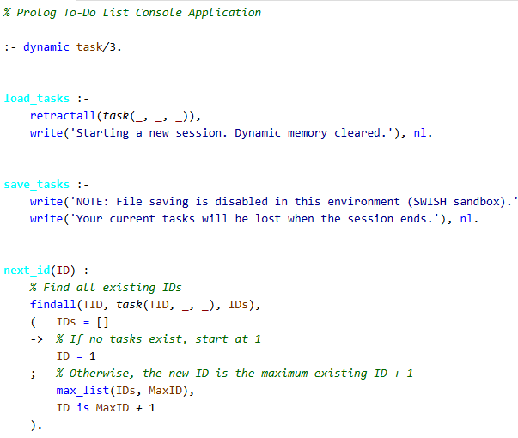
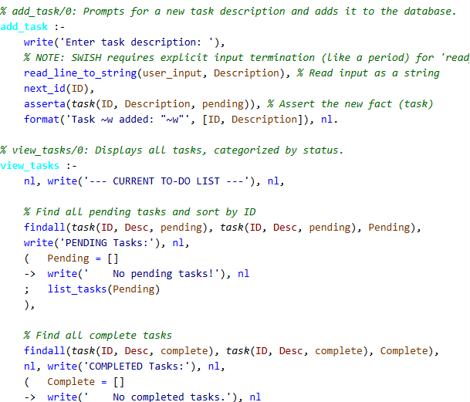
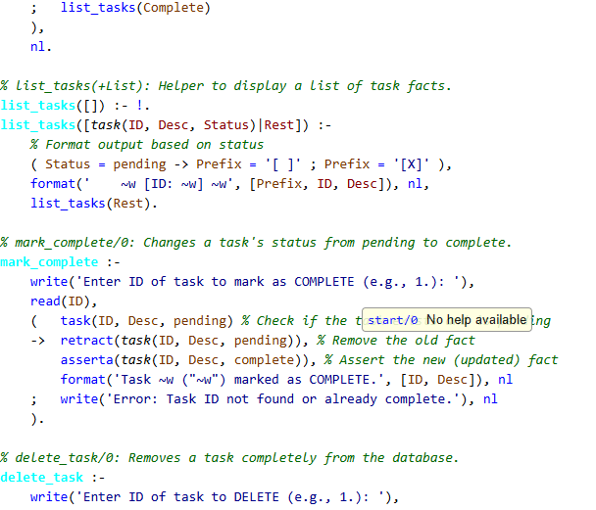
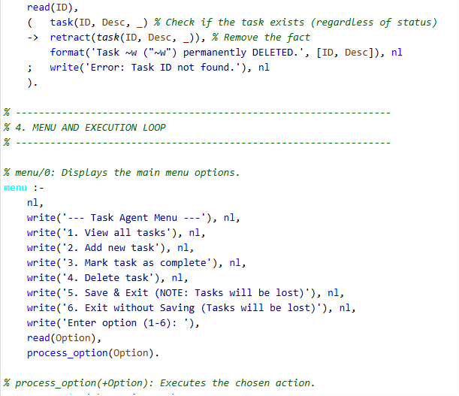
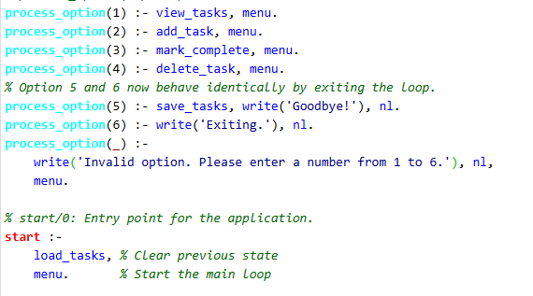
OUTPUT
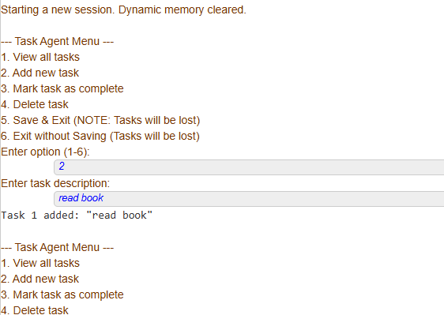
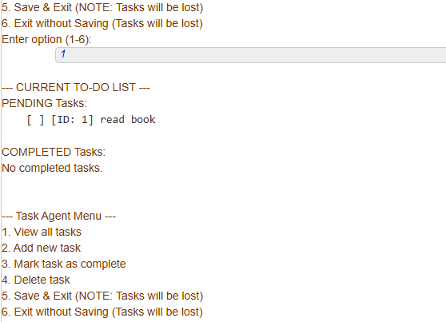
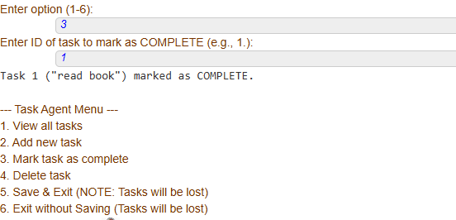

TESTING APPROACH
Unit tests:
- Test core predicates individually.
- Verify that each predicate handles both normal and edge cases(eg- adding the first task, marking a non-existing task).
Integration tests:
- Test sequences of operations to ensure correct transitions between states.
Validation tests:
- Confirm that all input handling properly validates user input and responds with appropriate prompts or error messages.
- Ensure the system runs smoothly in the intended environment.

CHALLENGES FACED
- Dynamic Memory Management
- Input Validation
- Session Persistence Limitations
- User Interface Design
- Unique ID Generation

LEARNING KEY AND TAKEAWAYS
- Gained practical experience using assert, retract, and dynamic predicates to manage runtime-modifiable facts.
- Developed skills in building user-friendly menu driven interfaces.
- Learned how to handle stateful data in a stateless language context.
- Understood the importance of validating user inputs and managing error scenarios gracefully to build reliable, user-friendly applications.

FUTURE ENHANCEMENTS
- Integrating the file-based or database storage to save tasks beyond the current session.

- Adding attributes for task priority levels and deadlines, enabling sorting and reminders to handle urgent tasks more effectively.

- Incorporating estimated time requirements per task and notify users about overdue or upcoming tasks.

